**Read Data from Excel in Selenium: Apache POI**

## What is Apache POI?

***Apache POI,  where POI stands for*** (Poor Obfuscation Implementation)  is an API that offers a collection of Java libraries that helps us to read, write, and manipulate different Microsoft files such as excel sheets, power-point, and word files.

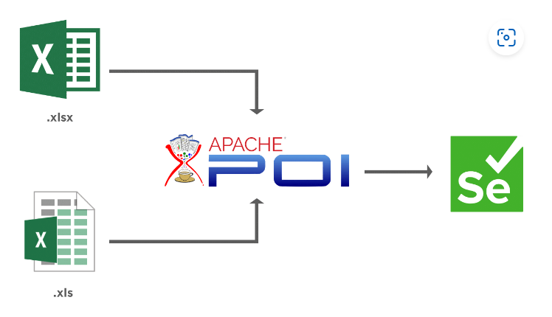

**package** Interview_Practice;

**import** java.io.FileInputStream;

**import** java.io.FileNotFoundException;

**import** java.io.IOException;

**import** org.apache.poi.xssf.usermodel.XSSFRow;

**import** org.apache.poi.xssf.usermodel.XSSFSheet;

**import** org.apache.poi.xssf.usermodel.XSSFWorkbook;

**public** **class** ReadWrite {

**public** **static** **void** main(String[] args) **throws** FileNotFoundException, IOException {

// File f = new File ("C://Users//Amol//Desktop//ExcelData.xlsx");

FileInputStream fs = **new** FileInputStream("C:/Users/Amol/Desktop/Excel_Data.xlsx");

System.***out***.println("Read Excel");

XSSFWorkbook wb = **new** XSSFWorkbook(fs);

XSSFSheet sheet1 = wb.getSheetAt(0);

//Print row and column value by giving row and column index

String data0 =sheet1.getRow(0).getCell(0).getStringCellValue();

System.***out***.println("Data from Excel: "+data0);

String data1 =sheet1.getRow(0).getCell(1).getStringCellValue();

System.***out***.println("Data from Excel: "+data1);

String data2 =sheet1.getRow(1).getCell(0).getStringCellValue();

System.***out***.println("Data from Excel: "+data2);

String data3 =sheet1.getRow(1).getCell(1).getStringCellValue();

System.***out***.println("Data from Excel: "+data3);

System.***out***.println("-----------------------------------------------------------");

//Print row and column values if we dont know row count but know column count

**int** j = sheet1.getLastRowNum();

**for**(**int** i = 0; i<=j; i++)

{

String value = sheet1.getRow(i).getCell(0).getStringCellValue();

String value1 = sheet1.getRow(i).getCell(1).getStringCellValue();

System.***out***.print(value+"\t\t");

System.***out***.println(value1+"\t\t");

}

System.***out***.println("-----------------------------------------------------------");

//Print row and column values if we dont know row count and column count

**int** rowCount = sheet1.getLastRowNum();

**for** (**int** i = 0; i <= rowCount; i++) {

XSSFRow row = sheet1.getRow(i);

**for** (**int** k = 0; k < row.getLastCellNum(); k++) {

//Print Excel data in console

System.***out***.print(row.getCell(k).getStringCellValue()+"|| ");

}

System.***out***.println();

}

System.***out***.println("Read Excel sheet successfully");

wb.close();

}

}